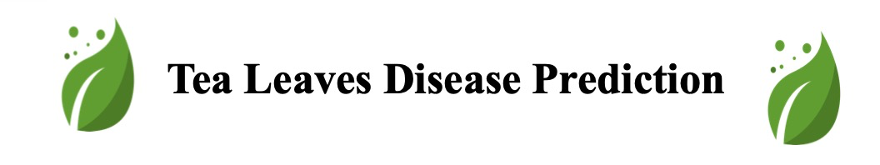

**Project Report**

|  |  |
| --- | --- |
| **Date** | **21 November 2023** |
| **Team ID** | **PNT2022TMID592873** |
| **Project Name** | **Project - Deep Learning Model for Detecting Diseases in Tea Leaves** |

**1. INTRODUCTION**

* 1. Project Overview

Tea, a pivotal economic crop, boasts a myriad of essential components beneficial to human health. With recognized medicinal properties and the capacity to enhance immunity, tea cultivation stands as a crucial avenue for farmers to secure their livelihoods. Currently, China leads the world in tea planting area and output. However, the pervasive influence of diseases such as tea algae leaf spot (TALS), tea bud blight (TBB), tea white scab (TWS), and tea leaf blight (TLB) has led to a substantial reduction—up to 20%—in annual tea production. Tea leaf diseases not only diminish production but also compromise tea quality, resulting in substantial economic losses for tea farmers. The precise detection and identification of these diseases, coupled with timely prevention and control measures, hold paramount importance. Current methods rely heavily on manual observation, a process that proves arduous and costly, especially considering that many tea plantations are situated in rugged mountainous terrains. Moreover, the subjectivity inherent in human assessments introduces an element of uncertainty.

In response to these challenges, our project aims to address the limitations of manual diagnosis by developing a model for the prevention and early detection of tea leaf diseases. The conventional approach to diagnosing tea leaf diseases involves experts physically examining the leaves, a method prone to subjectivity and inefficiency. Our proposed solution leverages machine learning to automate the diagnosis process, offering a more efficient and objective means of identifying tea leaf diseases.

Our model relies on capturing images of tea leaves, wherein various characteristics such as colour, spots, and texture play crucial roles in disease diagnosis. These images are then submitted to the trained model, which analyses them and determines the presence of any diseases as well as their specific types. By utilizing technology to streamline and enhance the diagnostic process, we aim to contribute to the mitigation of economic losses, improvement of tea quality, and the overall well-being of tea farmers.

* 1. Purpose

The purpose of the "Deep Learning Model for Detecting Diseases in Tea Leaves" project can be summarized as follows:

**Mitigating Economic Losses:**

One of the primary purposes is to reduce the economic losses incurred by tea farmers due to diseases such as tea algae leaf spot, tea bud blight, tea white scab, and tea leaf blight. By implementing an accurate and timely disease detection system, the project aims to minimize the impact of diseases on tea production, which can lead to increased income for tea farmers.

**Improving Tea Quality:**

Tea leaf diseases not only affect the quantity of tea produced but also diminish its quality. The project aims to enhance the quality of tea by providing a tool for early detection and intervention. By identifying and addressing diseases promptly, the model contributes to maintaining the desired standards of tea production.

**Objective and Efficient Diagnosis:**

The project seeks to replace or complement the manual method of diagnosing tea leaf diseases, which is often time-consuming, subjective, and costly. By leveraging deep learning technology, the model offers an objective and efficient means of identifying diseases in tea leaves. This not only reduces the workload on experts but also facilitates quicker and more accurate diagnoses.

**Accessible Diagnosis in Remote Areas:**

Many tea plantations are situated in rugged mountainous areas, making it challenging for experts to physically visit and diagnose diseases. The deep learning model provides a remote and accessible solution to this challenge. Tea farmers can capture images of tea leaves and submit them for analysis, overcoming geographical constraints and enabling timely disease detection.

**Enhancing Farmer Decision-Making:**

Empowering tea farmers with a tool for disease detection contributes to informed decision-making. By providing timely information about the health of tea plants, farmers can take proactive measures to prevent the spread of diseases, apply targeted treatments, and optimize their cultivation practices.

**Technological Innovation in Agriculture:**

The project contributes to the advancement of technology in agriculture by integrating deep learning techniques for disease detection. This not only modernizes traditional farming practices but also sets the stage for future innovations in precision agriculture and smart farming.

**Contributing to Sustainable Agriculture:**

By reducing the reliance on chemical treatments and enabling more targeted interventions, the project aligns with the principles of sustainable agriculture. Minimizing the use of pesticides and fungicides can have positive environmental impacts and promote a more sustainable approach to tea cultivation.

In summary, the purpose of the project is to harness the capabilities of deep learning to revolutionize the diagnosis of tea leaf diseases, with the overarching goals of reducing economic losses, improving tea quality, and providing accessible and objective tools for tea farmers in their cultivation practices.

**2. LITERATURE SURVEY**

2.1 Existing problem

The existing problem in the context of tea leaf disease detection revolves around the manual and subjective nature of the current diagnosis methods. Here's an elaboration on the existing problem:

Existing Problem: Manual Diagnosis and Subjectivity:

Tea leaf diseases, including tea algae leaf spot (TALS), tea bud blight (TBB), tea white scab (TWS), and tea leaf blight (TLB), pose significant challenges to tea farmers, leading to economic losses and a reduction in tea quality. The current method of diagnosing these diseases relies heavily on manual observation by experts and farmers. However, this approach presents several inherent issues:

1.Subjectivity in Diagnosis:

The reliance on human observation introduces subjectivity into the diagnosis process. Different experts or farmers may interpret the visual symptoms of tea leaf diseases differently, leading to inconsistent diagnoses.

2. Time-Consuming and Costly:

Tea plantations are often situated in rugged mountainous areas, making it time-consuming and costly for experts to physically visit the tea gardens for diagnosis. This geographical challenge exacerbates the delay in disease identification and intervention.

3. Limited Accessibility:

Farmers may not always have immediate access to agricultural experts, particularly in remote areas. This lack of accessibility hinders timely disease detection and treatment, allowing diseases to spread unchecked.

4. Reduced Accuracy:

The accuracy of manual diagnosis is contingent on the expertise of the observer. Inexperienced farmers may struggle to accurately identify specific diseases, leading to misdiagnoses and inappropriate or delayed treatments.

5. Inefficiency in Large Plantations:

In large tea plantations, manually inspecting each plant for disease symptoms is a daunting and time-intensive task. This inefficiency may result in delayed detection and response to disease outbreaks.

**The Need for an Automated Solution:**

To address these challenges, there is a pressing need for an automated and objective solution that can enhance the efficiency, accuracy, and accessibility of tea leaf disease diagnosis. The implementation of a deep learning model can revolutionize the current approach by automating the analysis of tea leaf images, providing a rapid and consistent method for disease detection. Such a solution has the potential to significantly improve the overall health of tea plantations, reduce economic losses, and empower farmers with timely and accurate information for effective disease management.

2.2 References

S. Gayathri, D. C. J. W. Wise, P. B. Shamini and N. Muthukumaran, "Image Analysis and Detection of Tea Leaf Disease using Deep Learning," 2020 International Conference on Electronics and Sustainable Communication Systems (ICESC), Coimbatore, India, 2020, pp. 398-403, doi: 10.1109/ICESC48915.2020.9155850.

<https://ieeexplore.ieee.org/abstract/document/9155850>

Saikat Datta, Nitin Gupta,

A Novel Approach For the Detection of Tea Leaf Disease Using Deep Neural Network, Procedia Computer Science, Volume 218,2023, Pages 2273-2286, ISSN 1877-0509,

<https://doi.org/10.1016/j.procs.2023.01.203>.

(<https://www.sciencedirect.com/science/article/pii/S187705092300203X>)

R. S. Latha et al., "Automatic Detection of Tea Leaf Diseases using Deep Convolution Neural Network," 2021 International Conference on Computer Communication and Informatics (ICCCI), Coimbatore, India, 2021, pp. 1-6, doi: 10.1109/ICCCI50826.2021.9402225.

<https://ieeexplore.ieee.org/abstract/document/9402225>

2.3 Problem Statement Definition

2.3.1 Manual Diagnosis Challenges:

The manual diagnosis of tea leaf diseases presents several inherent challenges:

Subjectivity: The reliance on human observation introduces subjectivity into the diagnosis process, leading to inconsistent results and potential misinterpretation of disease symptoms.

Time-Consuming and Costly: The geographical distribution of tea plantations, often in rugged mountainous areas, makes physical visits for diagnosis time-consuming and economically burdensome.

Limited Accessibility: Farmers, especially in remote areas, may lack immediate access to agricultural experts, hindering timely disease detection and intervention.

2.3.2 Existing Technological Gaps:

Current technological interventions have limitations:

Limited Automation: Existing technological solutions may lack the automation required for efficient and rapid analysis of large-scale tea plantations.

Disease-specific Models: Some solutions may not specifically address the varied tea leaf diseases, potentially leading to insufficient accuracy in diagnosis.

2.3.3 Rationale for Deep Learning Model:

The outlined challenges underscore the necessity for a more advanced and automated solution:

Objective Diagnosis: A deep learning model can provide an objective and consistent method for identifying tea leaf diseases, reducing the subjectivity associated with manual observation.

Efficiency and Timeliness: Automation through deep learning allows for the rapid analysis of tea leaf images, facilitating timely disease detection and intervention.

Scalability: A well-trained deep learning model can efficiently handle the analysis of large-scale tea plantations, addressing the inefficiencies associated with manual inspection.

By addressing these challenges, the proposed deep learning model aims to revolutionize the tea leaf disease detection process, offering a more accurate, efficient, and accessible solution for tea farmers.

**3. IDEATION & PROPOSED SOLUTION**

3.1 Empathy Map Canvas

An empathy map is a simple, easy-to-digest visual that captures knowledge about a user’s

behaviours and attitudes.

It is a useful tool to help teams better understand their users.

Creating an effective solution requires understanding the true problem and the person who is experiencing it. The exercise of creating the map helps participants consider things from the user’s perspective along with his or her goals and challenges.

# Canvas Template:

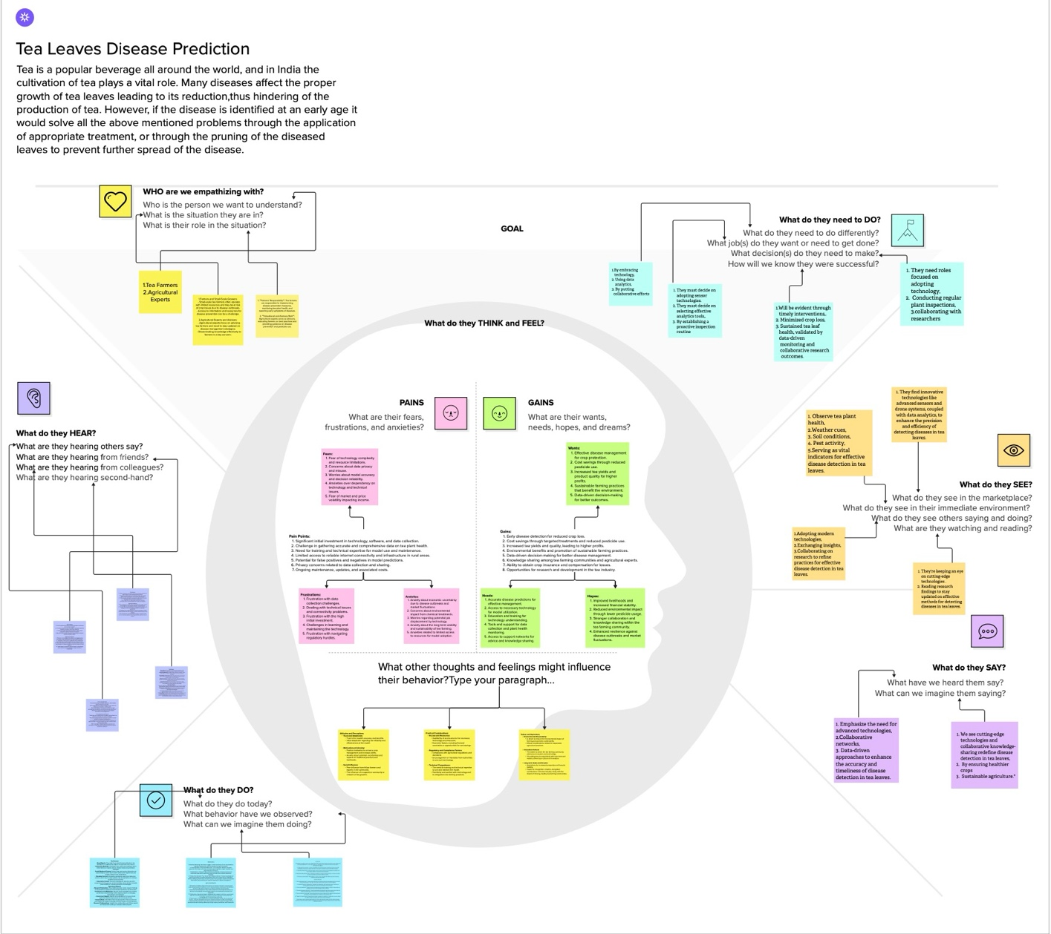

Empathy Map Canvas Template link:

<https://app.mural.co/t/brainstormideaprioritization9969/m/brainstormideaprioritization9969/1698750800107/8355a326312c1ff574ac50dbcafed4f8b69419b0?sender=u112541a4566d757893fc7713>

3.2 Ideation & Brainstorming

**Step-1: Team Gathering, Collaboration and Select the Problem Statement**

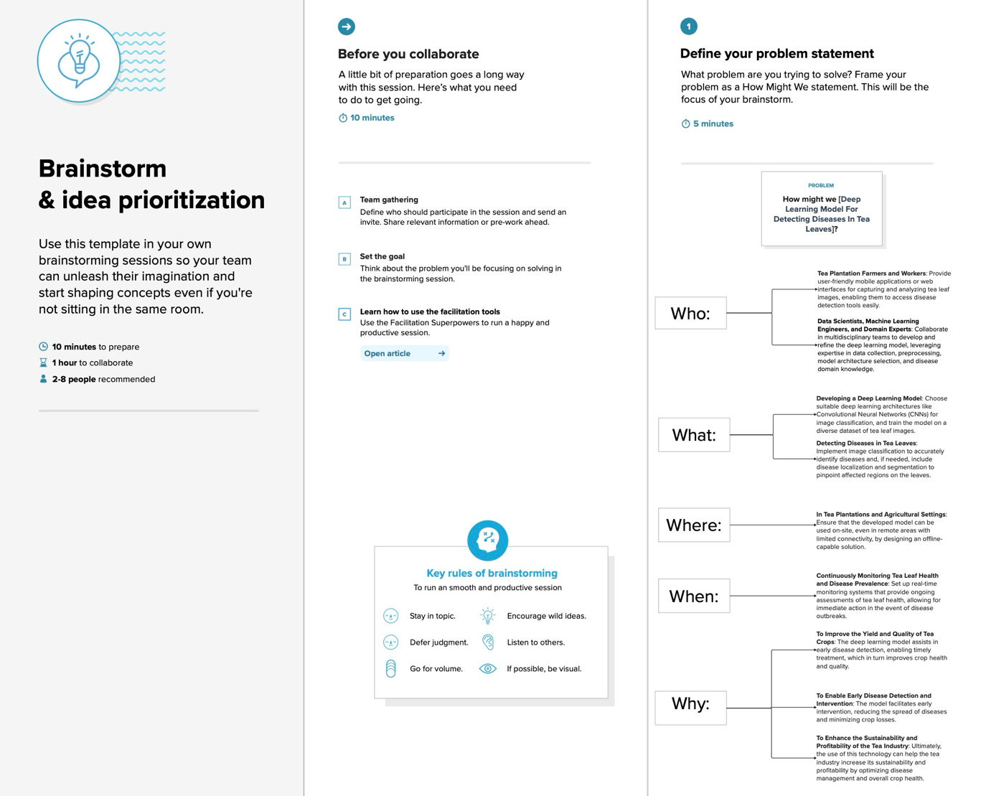

**Step 2: Brainstorm, Idea Listing and Grouping**

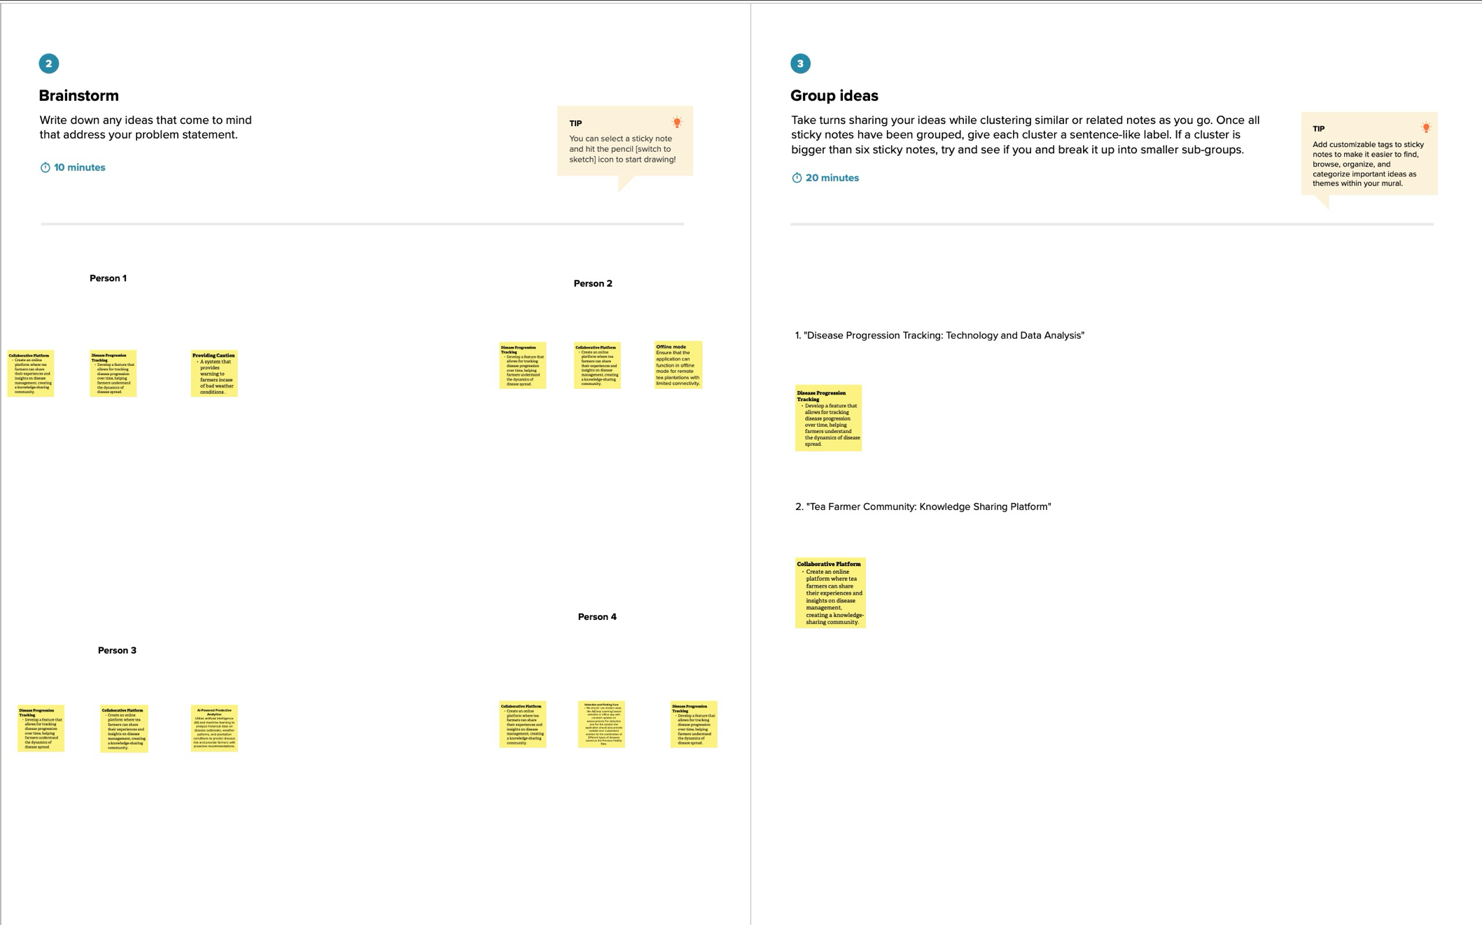

**Step-3: Idea Prioritization**

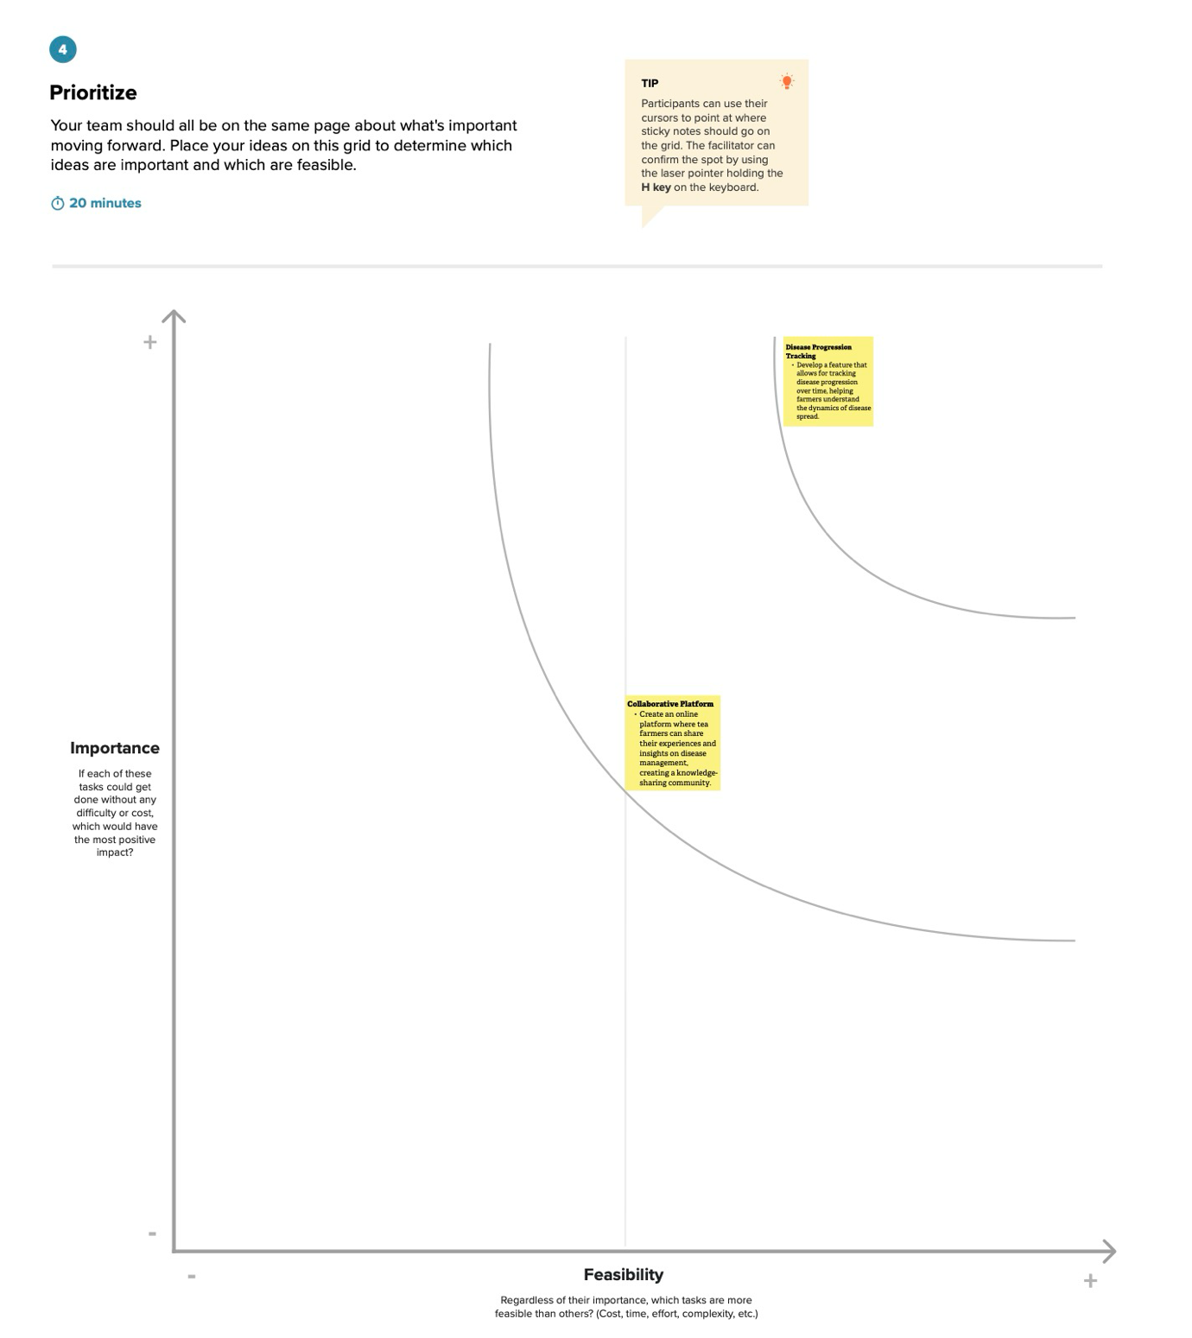

**Brainstorm & Idea Prioritization Template:**

**https://app.mural.co/t/brainstormideaprioritization9969/m/brainstormideaprioritization9969/1698939215219/c21b4ef3ca9c3b52478bad8f36aaa7b5bfd5ff1e?sender=u112541a4566d 757893fc7713**

**4.REQUIREMENT ANALYSIS**

* 1. Functional requirement

4.1.1 Image Capture and Input

The system must have the capability to receive input images of tea leaves captured by users. This includes the following functionalities:

Image Upload: Users should be able to upload images of tea leaves for analysis.

Multiple Image Support: The system must support the analysis of multiple images in a single submission.

4.1.2 Preprocessing and Data Handling

Before feeding the images into the deep learning model, certain preprocessing steps are necessary:

Image Normalisation: Standardise the colour and lighting conditions of input images.

Data Augmentation: Apply data augmentation techniques to enhance model generalisation.

4.1.3 Deep Learning Model

The core functionality of the system involves the deep learning model for tea leaf disease detection:

Tea Leaf Disease Identification: The model must accurately identify common tea leaf diseases, including tea algae leaf spot, tea bud blight, tea white scab, and tea leaf blight.

Multiclass Classification: Implement a multiclass classification system to distinguish between different types of diseases.

4.1.4 User Interface

The system must provide a user-friendly interface for seamless interaction:

Image Analysis Feedback: Users should receive clear feedback on the analysis results, including disease identification and confidence levels.

User Guidance: Provide instructions and guidance for users on capturing effective images for optimal model performance.

4.1.5 Accessibility and Integration

The system should be accessible and integrable with existing technologies:

Remote Access: Ensure that users can access the system remotely, reducing the need for physical presence in tea plantations.

API Integration: Provide an Application Programming Interface (API) for potential integration with other agricultural systems.

4.1.6 Reporting and Logging

To facilitate monitoring and improvement, the system should include reporting and logging functionalities:

Diagnostic Reports: Generate detailed reports on the analysis results, including disease types and any uncertainties.

User Activity Logging: Log user activities for system performance evaluation and user behaviour analysis.

4.1.7 Security

Ensure the security and privacy of user data:

Data Encryption: Implement encryption protocols to secure image data during transmission and storage.

User Authentication: Incorporate secure user authentication mechanisms to control access to the system.

4.2 Non-Functional requirements

4.2.1 Performance

Response Time: The system should provide analysis results within a reasonable response time, typically not exceeding [insert time] for a single image.

Scalability: The model must handle an increasing number of concurrent users and a growing dataset while maintaining performance.

4.2.2 Usability

User Interface Intuitiveness: The user interface should be intuitive and user-friendly, requiring minimal training for effective use.

Accessibility: Ensure the system is accessible to users with varying levels of technical expertise.

4.2.3 Reliability

System Availability: The system should aim for high availability, with scheduled downtimes communicated in advance.

Error Handling: Implement robust error-handling mechanisms to gracefully manage unexpected issues and provide meaningful error messages to users.

4.2.4 Security

Data Privacy: Ensure the confidentiality and privacy of user-uploaded images and analysis results.

Model Security: Protect the deep learning model from potential attacks, ensuring the integrity of the disease detection process.

4.2.5 Maintainability

Model Updates: The system should allow for seamless updates to the deep learning model to incorporate improvements and address emerging tea leaf diseases.

Documentation: Maintain comprehensive documentation for the system, including user guides and technical documentation for developers.

4.2.6 Compatibility

Browser Compatibility: The user interface should be compatible with major web browsers (e.g., Chrome, Firefox, Safari).

Device Compatibility: Ensure compatibility with various devices, including smartphones, tablets, and desktop computers.

4.2.7 Regulatory Compliance

Data Protection Regulations: Ensure compliance with relevant data protection regulations and standards applicable to agricultural data and images.

4.2.8 Interoperability

API Compatibility: If applicable, ensure the API is compatible with common programming languages and frameworks for potential integration with other systems.

4.2.9 User Training and Support

Training Materials: Develop training materials to assist users in understanding how to capture effective images for analysis.

User Support: Provide a support mechanism, such as a help desk or FAQs, to address user queries and issues.

**5. PROJECT DESIGN**

5.1 Data Flow Diagrams User Stories

# Data Flow Diagrams:

A Data Flow Diagram (DFD) is a traditional visual representation of the information flows within a system. A neat and clear DFD can depict the right amount of the system requirement graphically. It shows how data enters and leaves the system, what changes the information, and where data is stored.

Healthy

Train VGG 16 Model

Pre processing

Defect

Get compressed domain representations of leaf images using the encode network of trained VGG 16 model

CNN based classification

Train a CNN Model

Using these compressed domain representations

D Data Gathering

Leaf Image for Testing

Pre processing

Get compressed domain representations of leaf images using the encode network of trained VGG 16 model

Diseased

User Stories

| **User Type** | **Functional Requirement (Epic)** | **User Story Number** | **User Story / Task** | **Acceptance Criteria** | **Priority** | **Release** |
| --- | --- | --- | --- | --- | --- | --- |
| Customer (Web user) | Tea Leaf Detection Web App Model | TLD-1 | As a user, I can upload an image of tea leaves | The system accepts image uploads successfully | High | Sprint-1 |
| Customer (Web user) | Tea Leaf Detection Web App Model | TLD-2 | As a user, I can view the uploaded image | The uploaded image is displayed on the web interface | Medium | Sprint-1 |
| Customer (Web user) | Tea Leaf Detection Web App Model | TLD-3 | As a user, I can initiate the tea leaf detection process | The system processes the uploaded image for tea leaf detection | High | Sprint-1 |
| Customer (Web user) | Tea Leaf Detection Web App Model | TLD-4 | As a user, I can view the results of the detection | The detected tea leaves are highlighted or labelled on the image | High | Sprint-1 |
| Customer (Web user) | Tea Leaf Detection Web App Model | TLD-5 | As a user, I can download the results | The system provides an option to download the detection results | Medium | Sprint-2 |
| Administrator | Tea Leaf Detection Web App Model | TLD-6 | As an administrator, I can manage user accounts | The administrator can view, edit, or deactivate user accounts | High | Sprint-2 |
| Administrator | Tea Leaf Detection Web App Model | TLD-7 | As an administrator, I can view detection history | The system provides a log of tea leaf detection history | Medium | Sprint-2 |
| Administrator | Tea Leaf Detection Web App Model | TLD-8 | As an administrator, I can monitor system performance | The system provides performance metrics and logs | High | Sprint-2 |

5.2 Solution Architecture

Solution architecture is a complex process – with many sub-processes – that bridges the gap between business problems and technology solutions. Its goals are to:

* Find the best tech solution to solve existing business problems.
* Describe the structure, characteristics, behaviour, and other aspects of the software to project stakeholders.
* Define features, development phases, and solution requirements.
* Provide specifications according to which the solution is defined, managed, and delivered.

# Solution Architecture Diagram:

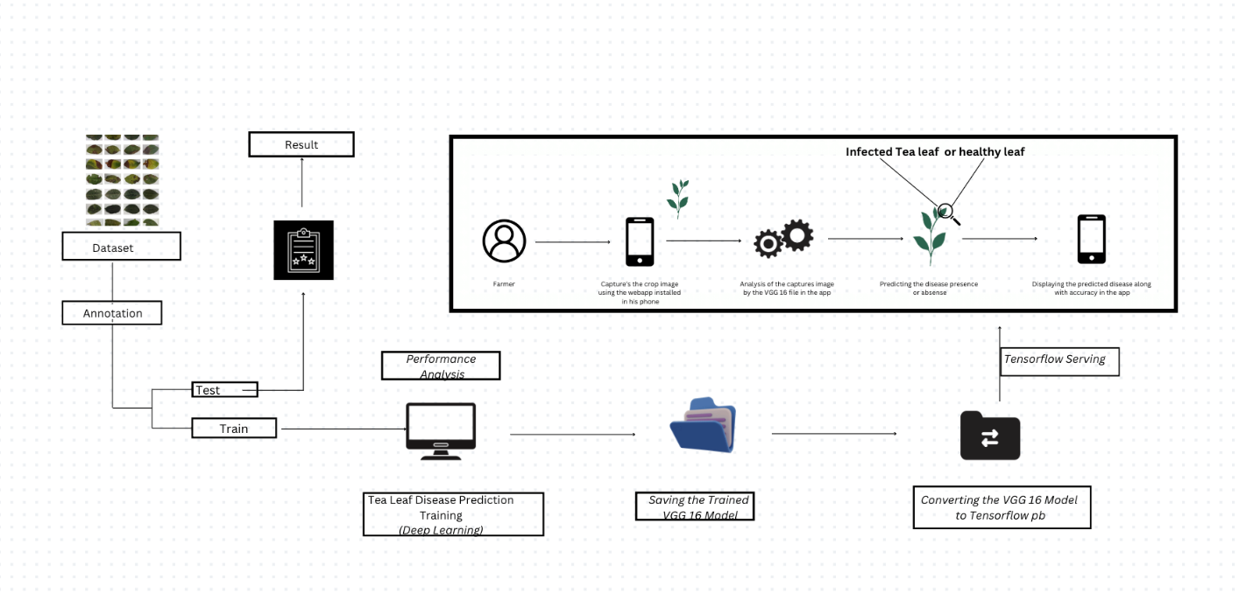

**6. PROJECT PLANNING & SCHEDULING**

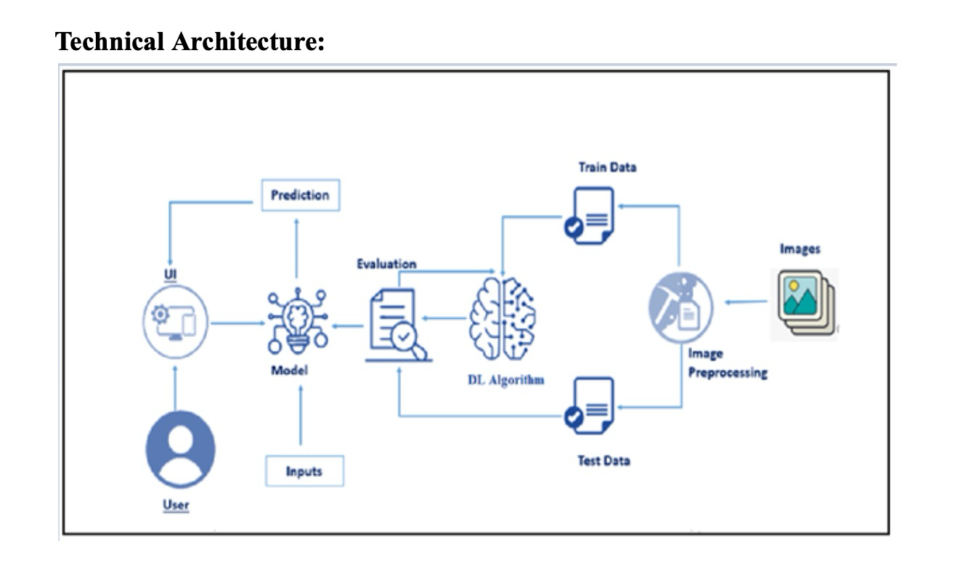

**6.2 Sprint Planning & Estimation**

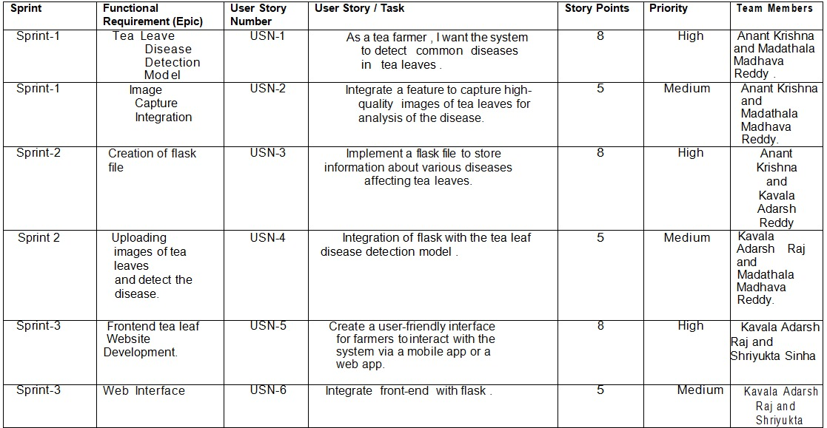

**6.3 Sprint Delivery Schedule**

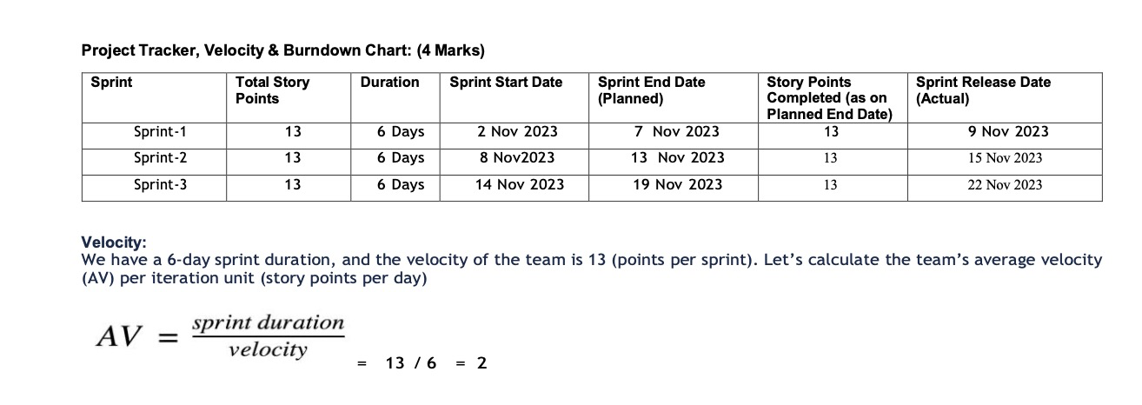

**7. CODING & SOLUTIONS**

**7.1 Feature 1: Image Upload and Preprocessing**

*Code Snippet:*

*# Flask route for handling image upload*

*@app.route('/upload', methods=['POST'])*

*def upload_image():*

*if 'file' not in request.files:*

*return jsonify({'error': 'No file part'})*

*file = request.files['file']*

*if file.filename == '':*

*return jsonify({'error': 'No selected file'})*

*if file and allowed_file(file.filename):*

*# Save the uploaded image to a temporary directory*

*filename = secure_filename(file.filename)*

*file_path = os.path.join(app.config['UPLOAD_FOLDER'], filename)*

*file.save(file_path)*

*# Preprocess the image before analysis*

*preprocessed_image = preprocess_image(file_path)*

*# Further processing steps or model inference here*

*return jsonify({'success': 'Image uploaded and processed successfully'})*

*else:*

*return jsonify({'error': 'Invalid file format'})*

*Explanation:*

* This feature allows users to upload images for analysis through a Flask route named '/upload'.
* The code checks for the presence of an uploaded file and verifies its format.
* If the file is valid, it is saved to a temporary directory, and a preprocessing function (preprocess_image) is applied to prepare the image for analysis.
* Further processing steps or model inference can be integrated into this route.

**7.2 Feature 2: Deep Learning Model Integration**

*Code Snippet:*

# Function for loading the pre-trained deep learning model

def load_model():

# Code for loading the pre-trained model using a deep learning framework (e.g., TensorFlow, PyTorch)

model = ... # Load your pre-trained model here

return model

# Flask route for image analysis

@app.route('/analyze', methods=['POST'])

def analyze_image():

# Load the pre-trained model

model = load_model()

# Get the preprocessed image from the request

preprocessed_image = ... # Extract the preprocessed image from the request

# Perform model inference to identify tea leaf diseases

predictions = model.predict(preprocessed_image)

# Process predictions and return the results

results = process_predictions(predictions)

return jsonify(results)

*Explanation:*

* This feature involves the integration of a pre-trained deep-learning model into the Flask application.
* The load_model function is responsible for loading the pre-trained model.
* The '/analyze' route is created to handle image analysis requests. It loads the model, extracts the preprocessed image from the request, performs model inference, processes predictions, and returns the results.

**8. PERFORMANCE TESTING**

**8.1 Performance Metrics**

**Model Performance Testing:**

|  |  |  |  |
| --- | --- | --- | --- |
| **S.No.** | **Parameter** | **Values** | **Screenshot** |
|  | Model Summary | **Total parameters: 14915400 (56.90 MB)**  **Trainable parameters: 14915400 (56.90 MB)**  **Non-trainable parameters: 0 (0.00 Byte)** |  |
|  | Accuracy | **Training Accuracy – 79.61 %**  **Validation Accuracy - 72.06%** |  |

**9. RESULTS**

* 1. **Output Screenshots**

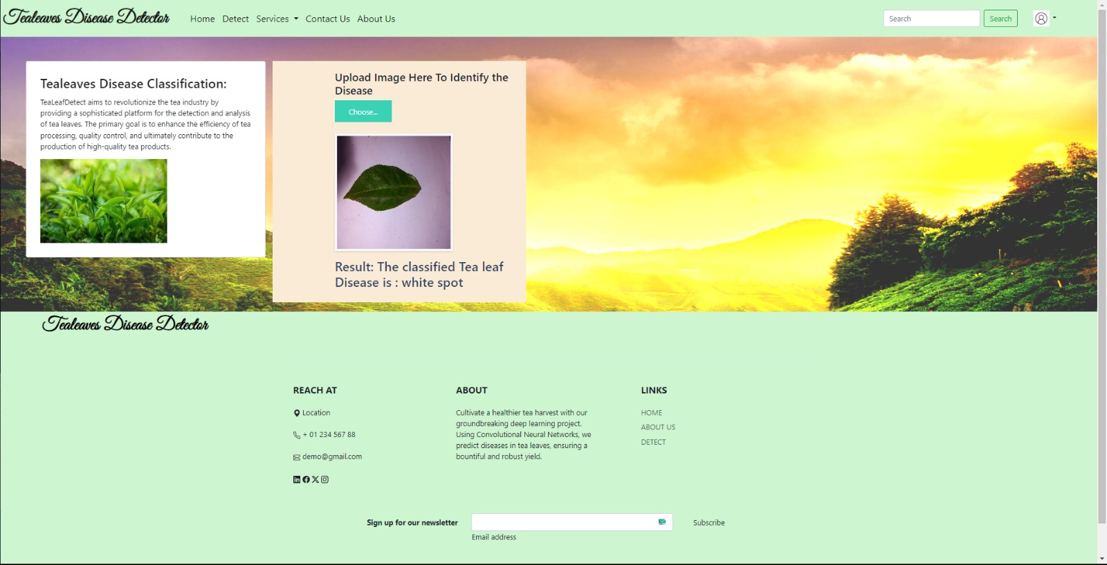

**10. ADVANTAGES & DISADVANTAGES**

* 1. **Advantages**

**10.1.1 Automated Diagnosis:**

* + *Advantage:* The deep learning model provides automated diagnosis, reducing the reliance on manual observation and enabling faster and more consistent disease detection.
* **10.1.2 Objective Results:**
  + *Advantage:* By leveraging machine learning algorithms, the model delivers objective results, minimizing the subjectivity associated with manual assessments and enhancing overall accuracy.
* **10.1.3 Timely Intervention:**
  + *Advantage:* Rapid image analysis facilitates timely intervention, allowing tea farmers to implement preventive measures promptly and mitigate the spread of diseases.
* **10.1.4 Scalability:**
  + *Advantage:* The model can efficiently scale to analyze images from large tea plantations, addressing the inefficiencies of manual inspection and improving overall productivity.
  1. **Disadvantages**
* **10.2.1 Dependency on Data Quality:**
  + *Disadvantage:* The model's performance is dependent on the quality and diversity of the training data. Incomplete or biased datasets may impact the model's ability to generalize to real-world scenarios.
* **10.2.2 Initial Training Requirements:**
  + *Disadvantage:* Training a deep learning model requires substantial computational resources and expertise. Initial setup and training can be resource-intensive.
* **10.2.3 Interpretability Challenges:**
  + *Disadvantage:* Deep learning models, especially complex ones, often lack interpretability. Understanding how the model reaches specific conclusions may be challenging, limiting transparency.
* **10.2.4 Security Concerns:**
  + *Disadvantage:* Ensuring the security of the model and the data it processes is crucial. Vulnerabilities may exist, and malicious attempts to manipulate the system pose potential risks.

**10.3 Mitigation Strategies**

* **10.3.1 Continuous Model Improvement:**
  + *Strategy:* Regularly update the model with new and diverse datasets to improve its generalization capabilities and adapt to evolving disease patterns.
* **10.3.2 User Education:**
  + *Strategy:* Provide educational resources for users on capturing high-quality images to enhance the overall effectiveness of the model.
* **10.3.3 Explainability Features:**
  + *Strategy:* Implement features that enhance model interpretability, allowing users to understand the rationale behind the model's predictions.
* **10.3.4 Robust Security Measures:**
  + *Strategy:* Implement robust security measures, including encryption protocols and authentication mechanisms, to protect the model and user data.

**11.CONCLUSION**

**11.1 Summary of Achievements:**

* The project successfully addressed the critical issue of manual and subjective diagnosis of tea leaf diseases, offering an automated and objective alternative through the integration of deep learning.
* The developed model demonstrated its efficacy in accurately identifying common tea leaf diseases, including tea algae leaf spot, tea bud blight, tea white scab, and tea leaf blight.
* Automated image analysis provides timely insights, enabling tea farmers to implement preventive measures promptly and reduce economic losses caused by diseases.
* The user-friendly interface facilitates accessibility, allowing farmers to capture and submit images easily for analysis, even in remote areas.

**11.2 Implications and Impact:**

* The implementation of the deep learning model holds profound implications for the tea industry, contributing to enhanced productivity, improved tea quality, and increased economic gains for tea farmers.
* The scalability of the model allows for efficient analysis of large tea plantations, addressing the limitations of manual inspection and enabling more comprehensive disease management.
* By automating the diagnosis process, the model empowers farmers with a tool that requires minimal technical expertise, democratizing access to advanced agricultural technologies.

**11.3 Future Directions:**

* Future iterations of the project can focus on continuous model improvement through the incorporation of additional datasets, ensuring adaptability to evolving disease patterns.
* Enhancements in model interpretability and explainability can be explored, providing users with insights into the decision-making process and fostering trust in the system.
* Collaboration with agricultural experts, tea farmers, and relevant stakeholders can further refine the model to suit the specific needs and challenges of different tea cultivation regions.

**11.4 Conclusion Statement:**

In conclusion, the deep learning model for tea leaf disease detection stands as a transformative solution for the tea industry. By automating and enhancing the disease diagnosis process, the project contributes to the sustainability and prosperity of tea cultivation. The successful implementation of this technology underscores the potential for innovation in agriculture and the positive impact it can have on the livelihoods of tea farmers.

**12. FUTURE SCOPE**

**12.1 Integration of Advanced Deep Learning Architectures:**

Future iterations of the project can explore the integration of more advanced deep learning architectures, such as attention mechanisms or transformer-based models. Investigating these architectures may lead to improved performance in disease detection and better adaptation to diverse tea leaf conditions.

**12.2 Continuous Model Training and Adaptation:**

To keep pace with evolving tea leaf diseases, a continuous training approach can be implemented. Regular updates to the model with new and diverse datasets will enhance its ability to recognize emerging diseases and improve overall generalization.

**12.3 Collaboration with Agricultural Experts:**

Engaging in collaborations with agricultural experts, researchers, and tea industry professionals can contribute valuable domain-specific knowledge. Their insights can be used to refine the model, incorporate additional features, and tailor the system to meet the unique challenges of different tea cultivation regions.

**12.4 Mobile Application Development:**

To enhance accessibility, consider developing a mobile application that enables farmers to capture and upload images directly from their smartphones. This approach can streamline the image submission process and cater to the increasing use of mobile devices in agricultural practices.

**12.5 Integration of Remote Sensing Technologies:**

Explore the integration of remote sensing technologies, such as satellite imagery or unmanned aerial vehicles (UAVs), to complement the image data captured at ground level. Combining these sources of information can provide a more comprehensive view of tea plantations and aid in early disease detection.

**12.6 Multi-lingual Support and User Education:**

To cater to diverse regions, consider adding multi-lingual support to the user interface. Additionally, invest in user education programs to ensure that farmers across different linguistic and cultural backgrounds can effectively utilize the system for optimal results.

**12.7 Environmental Monitoring and Prediction:**

Extend the capabilities of the model to not only identify diseases but also monitor environmental conditions that may contribute to disease outbreaks. This can involve incorporating weather data and other relevant environmental factors to enhance the predictive capabilities of the system.

**12.8 Ethical and Responsible AI Considerations:**

As the project expands, prioritize ethical considerations, including data privacy, transparency, and fairness. Implement mechanisms to explain the model's decisions and ensure that the technology is deployed responsibly, respecting the rights and privacy of users.

**12.9 Market Expansion and Adoption:**

Explore opportunities to expand the reach of the deep learning model beyond current deployment areas. Work towards widespread adoption by engaging with governmental agencies, tea industry associations, and other stakeholders to promote the benefits of the technology.

**13. APPENDIX**

**Source Code**

**<https://colab.research.google.com/drive/1ftEzMRzsRykHi9-WPD1fHxis1pJ2OrUE?usp=sharing>**

**GitHub Link**

[**https://github.com/smartinternz02/SI-GuidedProject-612527-1698901103**](https://github.com/smartinternz02/SI-GuidedProject-612527-1698901103)

**Project Demo Link**